Tabla de contenido

HOME 2

About Us 3

Who is our team? 4

Contributions 4

Professionals 4

Organizations 4

Our Proposes 5

How to Contribution 6

Contact Us 6

Novel Coronavirus (2019-nCoV) Data Repository 7

# HOME

The COVID-19 Colombia Project collects and publishes the complete epidemiologic indicators and case data available for Colombia departments, municipalities, and cities. Besides, it is a space to show ideas or applications that help cope with the pandemic.

This website is a resource to help advance the understanding of the virus and inform the public, in order to save lives by making better decisions through monitoring the outbreak.

# About Us

The COVID-19 Colombia Project is a volunteer team dedicated to collecting and publishing the data required to understand the COVID-19 outbreak in Colombia. Besides, it is a space to show ideas or applications that help cope with the pandemic.

Since early April 2020, we have grown from a two-team with a spreadsheet to a project with dozen of volunteer data-gatherers, developers, scientists, students, professors, and other dedicated contributors.

Every day, we collect data on COVID-19 cases, deaths, and recoveries for all 32 departments and 6 regions in the Colombia Republic. The above accompanied by a set of epidemiological indicators such as mortality rate, hospitalization rate, active cases, total people hospitalized, among others.

Also, we present some ideas and applications to aid in outbreak expansion time. Here, we find Apps, WhatsApp robots, among other ideas that people get informed out about COVID-19 and know what to do in case of symptoms.

# Who is our team?

We want to thank all those organizations and professionals who helped with The COVID-19 Colombia Project. Their names and contact address are listed below.

## Contributions

### Professionals

Name | Email | GitHub | Contribution

-----|-------|--------|----------------------------------

Julio Mario Daza Escorcia | juliom.dazae@konradlorenz.edu.co | [@juliomariodaza](https://github.com/juliomariodaza) | Dataset creator: [covid_19_daily_reports](https://github.com/inHouse-SAS/inFruit/tree/master/covid_19_data_colombia/covid_19_daily_reports) and [covid_19_daily_reports](https://github.com/inHouse-SAS/inFruit/tree/master/covid_19_data_colombia/covid_19_time_series)

Elis Hading Daza Escorcia | mr.daza@ingenieros.com | [@MrDaza](https://github.com/MrDaza) | Dataset creator: [minsalud_covid_19_sit_rep_csvs](https://github.com/inHouse-SAS/inFruit/tree/master/covid_19_situation_reports/minsalud_covid_19_sit_rep_csvs) and [minsalud_covid_19_sit_rep_pdfs](https://github.com/inHouse-SAS/inFruit/tree/master/covid_19_situation_reports/minsalud_covid_19_sit_rep_pdfs)

Juan Pablo Escorcia Caballero | juane@uninorte.edu.co | | Dataset creator: covid_19_deaths_analisys_reports (Not available yet)

### Organizations

Institution | Research Center | City, Country

-----------------|----------------------------------|-------------------

Universidad Konrad Lorenz | Research Center for Mathematics and Engineering | Bogotá, Colombia.

in-house SAS | Research and Development | Bogotá, Colombia.

Universidad del Norte | School of Management | Barranquilla, Colombia.

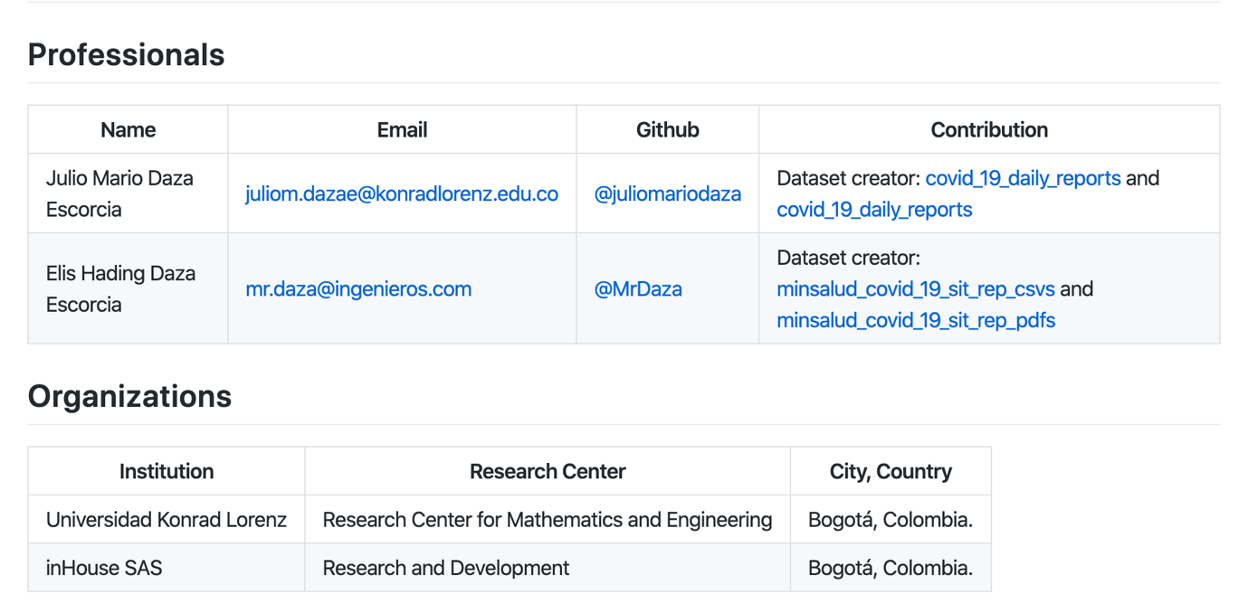

# Our Proposes

Please find below find the ideas and applications proposed by The COVID-19 Colombia Project to help understand the COVID-19 outbreak in Colombia and cope with the pandemic.

The COVID-19 Colombia Project is based on a group developer effort, with code hosted on GitHub including but not limited to these repositories:

[**Novel Coronavirus (2019-nCoV) Data Repository**](#_Novel_Coronavirus_(2019-nCoV))

Developed by Julio Daza, and Elis Daza.

Data repository for the 2019 Novel Coronavirus (formerly known as 2019-nCoV infection or simply COVID-19). The main objective of this repository is to facilitate access to COVID-19 data in Colombia to bring a more comprehensive picture of the current situation.

GitHub Watch

**App Covid19 Colombia**

Developed by Elis Daza.

Movil applications to aid in outbreak expansion time and help to that people get informed out about COVID-19 and know what to do in case of symptoms.

Download in Google Play

URLWatch soon

**A novel causal analysis of Colombia COVID-19 deaths**

Developed by Juan Escorcia, Milton Soto, Odette Chams, and Julio Daza.

Data repository for the coronavirus. This repository contains a causal analysis and epidemiologic indicators. The main objective is to determine the causal analysis of deaths from COVID-19 in Colombia and to bring a more comprehensive picture of the current situation.

GitHubWatch soon

URLWatch soon

**COVID-19 Colombia Visual Dashboard**

Developed by Julio Daza.

Visual Dashboard for the 2019 Novel Coronavirus (formerly known as 2019-nCoV infection or simply COVID-19). The main objective of this Dashboard is to facilitate access to COVID-19 data in Colombia to bring a more comprehensive picture of the current situation in all departments, municipals, and cities

URLWatch soon

# How to Contribution

If you want to contribute to GitHub repository: Welcome, it is a great pleasure for us to have your support!

Now, please **contact us** and tell us how you want to collaborate, or what you would like to do in The COVID-19 Colombia Project team.

Moreover, thank you, from all of us on the project, for caring about this work.

## Contact Us

If you have questions about the data or licensing conditions, please contact us at:

* Email: [CovidDataProject@gmail.com](mailto:CovidDataProject@gmail.com)
* Instagram: @CovidDataProject
* Twitter: @CovidDataPROJ

# Novel Coronavirus (2019-nCoV) Data Repository

The COVID-19 Colombia Project collects and publishes a series of data files with cumulative counts of coronavirus cases. The databases designed can be used to power any dashboard and serve in reporting tracking the virus for Colombia departments, municipalities, and cities.

The data record begins with the first reported coronavirus case in BOGOTA on Mar. 06, 2020. The data is based on reports the Ministry of Health (MINSALUD) and local news to provide a complete record of the ongoing outbreak

These datasets are being made available to the public interested as well as researchers, scientists, and government officials who would like to understand the outbreak better.

The COVID-19 Colombia Project proposes a novel coronavirus dataset that contains:

* Daily case reports with epidemiological indicators, such as mortality rate, hospitalization rate, active cases, total people hospitalized, among others.
* Time series files related to the cases confirmed, death, and recovered, respectively. For each file, each column of data includes the cumulative count from cases during the day.
* The daily case reports and time series contain a standard geographic identifier (latitude and longitude), to make it easier for an analyst to combine this data with other data sets like a map file or population data.
* The MINSALUD and INS provide folders with the COVID-19 official's reports. Additionally, a summary file with the daily official reports. This information is an excellent complement to our daily report.
* The information from COVID-19 official' reports has been cleaned and re-formatted to address inconsistencies in the time zone, update frequency, among other things more. All data is based on delivered through at official web sites and communications media.

For more information, please refer to our GitHub account: [@CovidDataProject.](https://github.com/CovidDataProject)